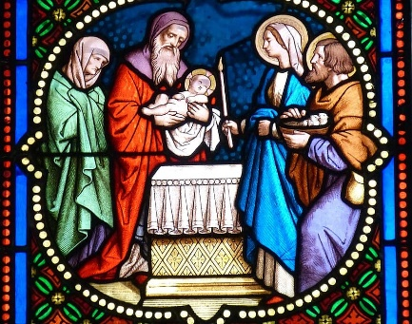
At the celebration of the Sacrament of Baptism, Godparents are present to represent the expanded spiritual family of the child and help the parents so that children will profess the faith of their family and live up to it. A Godparent is a person who assumes, along with the parents, the responsibility for the child's faith. The purpose is to ensure that the rich and beautiful faith of the Catholic Church is passed on to the child in the most loving and authentic way possible. As a Godparent, you must be able to live with integrity the Catholic faith handed on to you, as an example for your godchild
As a godparent, I meet the following criteria as set forth by the Church’s Code of Canon Law 874. I affirm that each of the following statements is true:
- I am at least sixteen years of age.
- I have received all sacraments of initiation: Baptism, Confirmation, Eucharist.
- I affirm that I am not the parent of the child to be baptized.
- I attend Mass often and live a life of faith in keeping with the role of a godparent.
- I fulfill my obligations to my parish to the best of my ability in response to the Gospel message.
- My current marital/living arrangement conforms to all laws, norms, and principles of the Roman Catholic Church.

Full legal name of Godparent______________________________________________________

Adress________________________________________________________________________

E-mail Adress__________________________________________________________________

With humility and gratitude, I will accept the responsibility and privilege of the role of godparent. I will pray to strengthen my own commitment to grow in faith and love in the Catholic Community. I do hereby solemnly declare that I fulfill all the above requirements to act as Godparent to:

Name of child to be baptized______________________________________________________

________________________________________ ________________________
Signature of Godparent Date

