**My Own Church Registration Guide**

Log into <https://louisville.parishsoftfamilysuite.com/Default.aspx>.

Click New User.

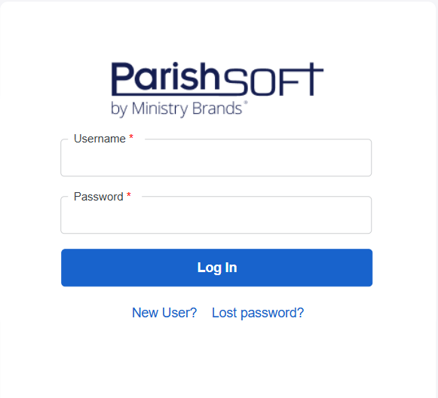

Fill out account information.

Once you submit registration, click “I agree” to the Terms of Use screen.

You should receive the following message on your screen.

Once submitted, the Parish Office will review your account and approve. You should then receive notification with a temporary password. Instructions for changing your password and navigating the site are available on the sfxmw.com website.