**My Own Church User Instructions**

Log into <https://louisville.parishsoftfamilysuite.com/Default.aspx>.

Sign in with temporary password. You are prompted to change it immediately.

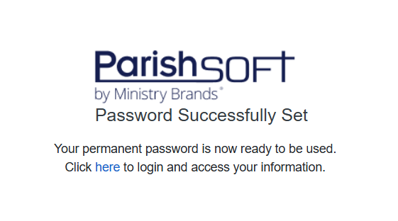

Agree to the Terms.

Allow cookies

Click on My Family

Click on Family Detail

Click on edit details to make any necessary changes.

**Make sure to click SAVE when finished.**

