St. Francis Xavier Church Presents:
Christ is the Light

Join your Friends and Neighbors for a Catholic Mission and
Faith Message filled with Fun and Inspiration

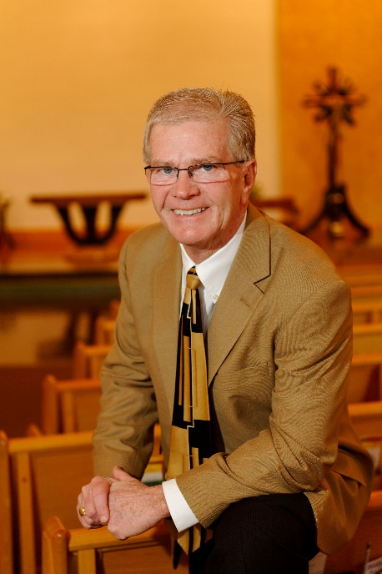
Leader: Gary Montgomery is a Louisville native and a member of St. Bernadette Parish. He retired as the Sports Director with WDRB-TV, Fox 41. He founded his speaking and training business 15 years ago. He has been teaching 8th grade in G.I.F.T for over 20 years. The Archdiocese of Louisville presented him with the Roncalli Award which recognizes excellence in catechesis. His presentation style is a combination of motivation, storytelling, fun and growing in our Catholic faith. He has presented at missions, retreats and church events throughout Kentucky and beyond.

Sunday, November 7: Find the Light @ 7:00 PM
Monday, November 8: Become the Light @ 7:00 PM
Tuesday, November 9: Give the Light Away @ 7:00 PM

“…his greatest assets are his deep faith and his passion for communicating the good news of Jesus Christ to others. I have heard Gary speak, and I highly recommend him for your speakers’ bureau. Gary has great gifts to bring to Church ministry and to any group who is fortunate to benefit from his witness.”
Most Reverend Joseph E. Kurtz, D.D.
Archbishop of Louisville

